TITLE OF THE PAPER IN UPPER CASE (Calibri Bold, 14 pt, centered)
Petar Petrović ¹, Marko Marković ¹
¹ Faculty of Technical Sciences, Graphic Engineering and Design, Novi Sad
(Calibri, 11 pt, Italic, centered)

Abstract: This is the guideline for submitting a paper for the 11th International Symposium on Graphic Engineering and Design, GRID24. (Calibri Light, Italic, 10pt)
Key words: symposium, guideline (Calibri Light, Regular, 10pt)
1. SECTION (INTRODUCTION) (Calibri, uppercase, 12pt)
Text: Calibri Light 10 pt, single spaced, justified. Titles (Calibri, uppercase, 12pt, space before and space after 12pt) and subsections (Calibri, Bold, 10pt, space before 12pt, space after 6pt) within the text should be numbered.
Paper size is A4 (210 x 297 mm). Margins are (mirror margins): TOP = 2,5 cm BOTTOM = 2,5 cm, INSIDE/OUTSIDE = 3 cm.
Language: English only.

2. SECTION (METHODS)
Figures/drawings must be integrated into text and also SENT SEPARATELY (300 PPI). Number all figures and tables and refer to them in the text as Figure 4 or Table 1. Titles in Calibri 9 pt, Italic should be placed bellow Figures (centered) and above Tables (align left). Text in Tables should be in Calibri Light, 9 pt.

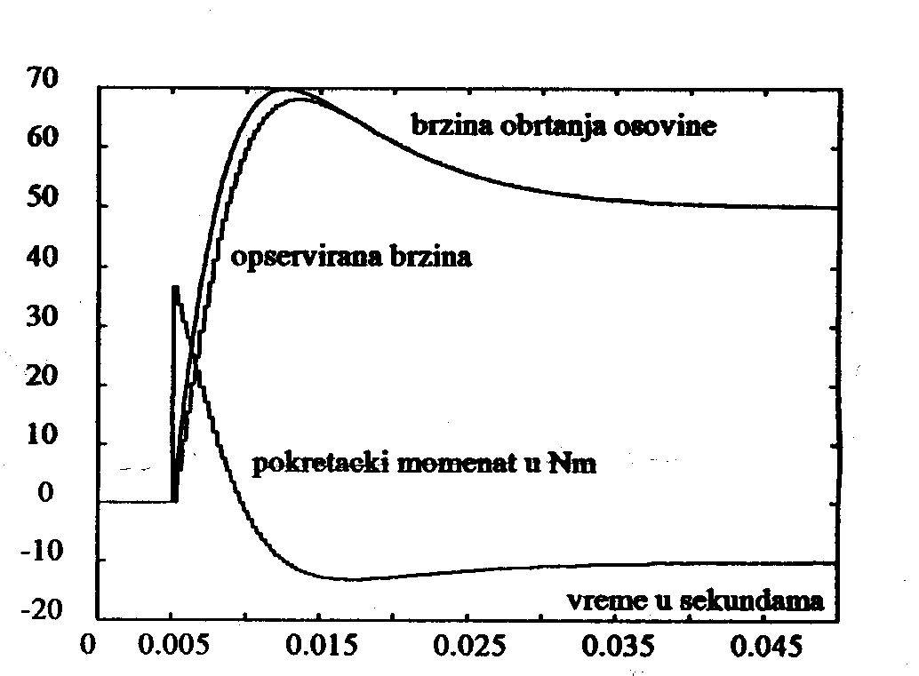

Figure 1: Simulation results

Table 1: Parameters and speed
 | Parameter 1 | Parameter 2 | Parameter 3
Speed 1 | 23 | 75 | 90
Speed 2 | 12 | 55 | 67

Number all your equations, as following (use either the Microsoft Equation Editor: Insert > Objects > Create New > Microsoft Equation > or MathType Equation):

$J\frac{dω\left(t\right)}{dt}+Fω\left(t\right)=T_{e}\left(t\right)−T_{o}\left(t\right)\text{.}$ (1)

Text that should be bulleted, define as following:

- Duis autem vel eum iriure dolor in hendrerit in vulputate velit esse molestie consequat, vel illum dolore eu feugiat

3. SECTION (RESULTS)
Ut wisi enim ad minim veniam, quis nostrud exerci tation ullamcorper suscipit lobortis nisl ut aliquip ex ea commodo consequat. Duis autem vel eum iriure dolor in hendrerit in vulputate velit esse molestie consequat, vel illum dolore eu feugiat nulla facilisis at vero eros et accumsan et iusto odio dignissim qui blandit praesent luptatum zzril delenit augue duis dolore te feugait nulla facilisi.
3.1 Subsection
Ut wisi enim ad minim veniam, quis nostrud exerci tation ullamcorper suscipit lobortis nisl ut aliquip ex ea commodo consequat. Duis autem vel eum iriure dolor in hendrerit in vulputate velit esse molestie consequat, vel illum dolore eu feugiat nulla facilisis at vero eros et accumsan et iusto odio dignissim qui blandit praesent luptatum zzril delenit augue duis dolore te feugait nulla facilisi.
4. SECTION (DISCUSSION)
Nam liber tempor cum soluta nobis eleifend option congue nihil imperdiet doming id quod mazim placerat facer possim assum. Lorem ipsum dolor sit amet, consectetuer adipiscing elit, sed diam nonummy nibh euismod tincidunt ut laoreet dolore magna aliquam erat volutpat. Ut wisi enim ad minim veniam, quis nostrud exerci tation ullamcorper suscipit lobortis nisl ut aliquip ex ea commodo consequat. Duis autem vel eum iriure dolor in hendrerit in vulputate velit esse molestie consequat, vel illum dolore eu feugiat nulla facilisis.
5. SECTION (CONCLUSIONS)
At vero eos et accusam et justo duo dolores et ea rebum. Stet clita kasd gubergren, no sea takimata sanctus est Lorem ipsum dolor sit amet. Lorem ipsum dolor sit amet, consetetur sadipscing elitr, sed diam nonumy eirmod tempor invidunt ut labore et dolore magna aliquyam erat, sed diam voluptua. At vero eos et accusam et justo duo dolores et ea rebum. Stet clita kasd gubergren, no sea takimata sanctus est Lorem ipsum dolor sit amet. Lorem ipsum dolor sit amet, consetetur sadipscing elitr, At accusam aliquyam diam diam dolore dolores duo eirmod eos erat, et nonumy sed tempor et et invidunt justo labore Stet clita ea et gubergren, kasd magna no rebum. sanctus sea sed takimata ut vero voluptua. est Lorem ipsum dolor sit amet. Lorem ipsum dolor sit amet, consetetur sadipscing elitr, sed diam nonumy eirmod tempor invidunt ut labore et dolore magna aliquyam erat.
6. ACKNOWLEDGMENTS
Use the singular heading even if you have many acknowledgments.
7. REFERENCES (Alphabetically ordered, Align Left)*
British Standards Institution. (2003) BS 5950-8:2003. Structural use of steelwork in building: code of practice for fire resistant design. London, British Standards Institution.
Chhibber, P. K. & Majumdar, S. K. (1999) Foreign ownership and profitability: Property rights, control, and the performance of firms in Indian industry. Journal of Law & Economics. 42 (1), 209-238. Available from: doi: 10.1086/467423
European Space Agency. (2015) Rosetta: rendezvous with a comet. Available from: http://envisat.esa.int/ [Accessed 15th june 2015]
Leckenby, R .J. (2005) Dynamic characterisation and fluid flow modelling of fractured reservoirs. PhD thesis. Imperial College London.
Partridge, H. & Hallam, G. (2007) Evidence-based practice and information literacy. In: Lipu, S., Williamson, K. & Lloyd, A. (eds.) Exploring methods in information literacy research. Wagga Wagga, Australia, Centre for Information Studies, pp. 149-170.
Simons, N. E., Menzies, B. & Matthews, M. (2001) A Short Course in Soil and Rock Slope Engineering. London, Thomas Telford Publishing.
Williams, M. (2004) Footwear hanger. UK Intellectual Property Office GB2409807 (Patent).
Wittke, M. (2006) Design, construction, supervision and long-term behaviour of tunnels in swelling rock. In: Van Cotthem, A., Charlier, R., Thimus, J.-F. and Tshibangu, J.-P. (eds.) Proceedings of the International Symposium of the International Society for Rock Mechanics, EUROCK 2006, 9-12 May 2006, Liège, Belgium. London, Taylor & Francis. pp. 211-216.

NOTE: When submitting final version of your paper on proper e – mail address (grid_info@uns.ac.rs), name it as following:

Familynameoffirstauthor_Familynameofsecondauthor_etc._FINAL.doc (docx)

* After each reference example, there is an Endnote carrying information about reference type
Standard
Journal Article (provide doi number if it exists)
Web Page
Thesis
Chapter in Edited Book
Book
Patent
Conference Paper

